# Philosophy of the scenarios

Current Sierra Nevada forests are overstocked (North et al. 2022), mostly due to the harvesting of large trees and fire suppression, which have allowed stand biomass to increase at the same time that size distributions are shifted towards smaller trees. These stands, well above their equilibrium stand density, are prone to correction by drought, insect outbreaks, and high-severity wildfire. The goal of these treatments is to gently reduce stand density and shift the size-distributions to the right, instead of allowing disturbances to do it for us. With luck, this will reduce the severity of disturbances and reintroduce a sustainable disturbance regime which regulates stand density without catastrophic impacts.

# Step 1: Deriving MaxSDI from FIA data

In order to estimate the %MaxSDI for each site within the study area, we derived the MaxSDI for a variety of site types from Forest Inventory and Analysis (FIA) data and LANDFIRE Biophysical Settings (BPS) layers. We constructed density-management diagrams for the FIA data within the Sierra Nevada and used quantile regression to determine the exponent and intercept of the self-thinning line. We then calculated MaxSDI using the equation of the self-thinning line for each BPS, substituting QMD = 10 in, using quantile regression (95th percentile); this is the intersection of the self-thinning line with the vertical line at QMD = 10 in. in the density-management diagram (Figure 1). The overall self-thinning line for all FIA sites in the Sierra Nevada was log(TPA) = -1.611 log(Dq) + 4.318. The coefficient for QMD is nearly identical to that of Reineke (1933), who found an exponent of -1.605, and is similar to the -3/2 self-thinning rule of Yoda et al. (1963).

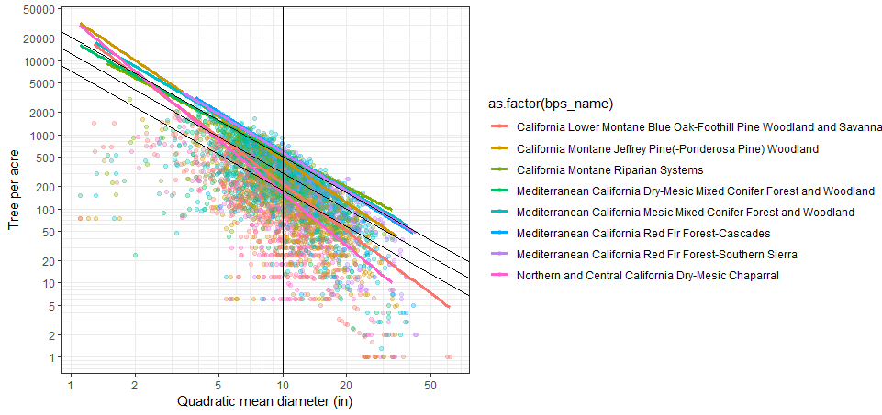

Figure 1. Density-management diagram for the most common biophysical settings (BPS) in the Sierra Nevada. Each colored line indicates the self-thinning line (max SDI line) for each BPS. The black lines indicate the self-thinning line for all plots combined (100% MaxSDI), 60% MaxSDI, and 35% MaxSDI. Each point represents one FIA plot. The intersection of each line with QMD = 10 in. (vertical line) is the SDI represented by the line. All forested plots are included, not only fully-stocked stands.

In order to validate this approach, we also estimated MaxSDI using the method of Reineke (1933), by assuming the slope of the self-thinning line to be -1.605. We solved for the approximate maximum value of *k* using quantile regression, using the 95th percentile of k to represent the maximum.

$$\log\left(N\right)= -1.605\log\left(D_{q}\right)+k$$

$$k=N∙{D_{q}}^{1.605}$$

Both methods generated equivalent estimates of MaxSDI for each BPS type (Fig. 2).

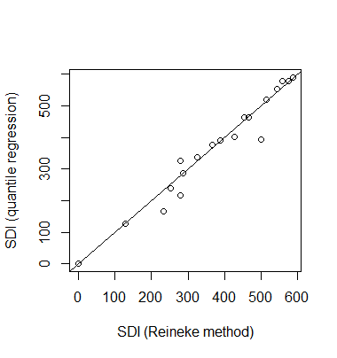

Figure 2. Relationship between two methods of calculating SDI. Each point represents a LANDFIRE Biophysical Setting (BPS). Within each BPS, each SDI for each FIA plot was calculated using both methods. MaxSDI was estimated as the 99th percentile of SDI using each method.

From these regressions, we can generate a map of MaxSDI for the study area, by mapping the MaxSDI for each BPS to a map of BPS (Fig. 3). From this map, we can generate 35% and 60% MaxSDI targets for the landscape.

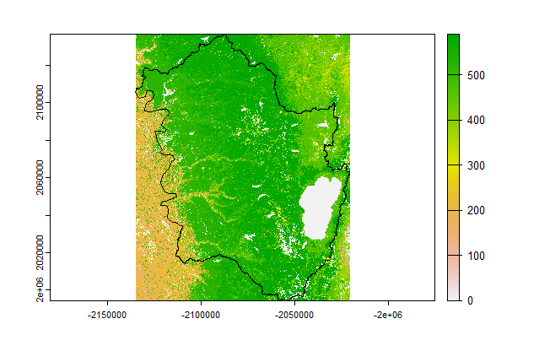

Figure 3. MaxSDI mapped for the central Sierra study area. The highest MaxSDI values are found in red fir and Sierra mixed-conifer stands at higher elevations, with lower MaxSDI in Jeffrey/Ponderosa pine forests, and the lowest MaxSDI in oak woodlands, shrublands, and riparian vegetation at low elevations.

# Step 2: Deriving a relationship to estimate plot SDI from LANDIS-II Cohorts

The next step needed is to estimate SDI from LANDIS-II format data. LANDIS-II (using the Net Ecosystem Carbon and Nitrogen extension) tracks ages and biomass of cohorts, rather than density and diameter of stands. We used regression equations fit to Forest Inventory and Analysis (FIA) data in order to estimate SDI from cohort data. We obtained FIA data represent stands within the Sierra Nevada which had not been recently harvested and which were >95% within a forested condition. We then coarsened the FIA data into age/biomass/species cohorts, as if they were a LANDIS-II site. We attempted to estimate site SDI using stand-level variables (mean age, total site biomass), but were unable to obtain a suitable model fit (R2 = 0.26, with biased residuals). Instead, we estimated the contribution of each cohort to site SDI, equivalent to the method of calculating SDI by summation (Shaw 2005). For each cohort, we calculated the SDI contribution of the cohort, which we summed to obtain the site SDI. We then fit regressions to predict SDIcohort from age, biomass, and a random intercept for species (Fig. 4). This model had an excellent fit (R2 = 0.98) after reconstructing site SDI from predicted cohort SDI. The model selected to represent cohort SDI was log(SDIcohort) = log(Biomass + Biomass2 + Biomass3) + log(Age + Age2 + Age3).

We validated this SDI reconstruction method by comparing predicted site-level SDI to observed site-level SDI (from FIA plots). We used FIA plots either selected from the entire Sierra Nevada or from TreeMap for the study area.

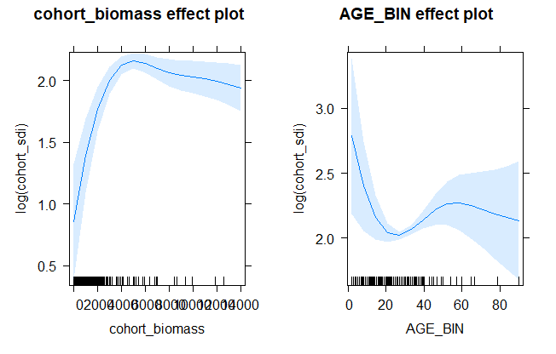

Figure 4. Relationship between cohort biomass, cohort age, and cohort SDI, used to estimate site-level SDI from LANDIS-II cohorts. 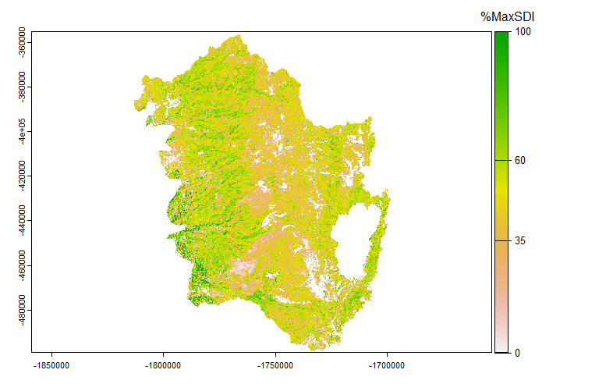

Figure 5. Percent MaxSDI of initial landscape used for LANDIS-II model runs, estimated using regression equations to estimate SDIcohort from the LANDIS-II age/biomass/species cohort list for each site.

# Step 3: Deriving biomass-to-maxSDI relationships for sites

We used a different set of regression equations to predict %MaxSDI from site biomass, stand age, and BPS (Fig. 5). Because the SDI ~ Biomass relationship differs according to stand age (i.e., the same biomass, if comprising larger trees, will have a lower SDI), we created biomass targets for four age classes: 0-20 years, 21-50 years, 51-100 years, and >101 years. As stands age, they are permitted to have a greater biomass than younger stands. This management strategy is equivalent to several widely used management strategies, including precommercial thinning or fuel reduction treatments which thin from below more intensively in younger stands. In the LANDIS-II scenarios, this will allow the reduction of fuels in young stands which are dominated by ladder fuel age classes (<20-30 years, approximately).

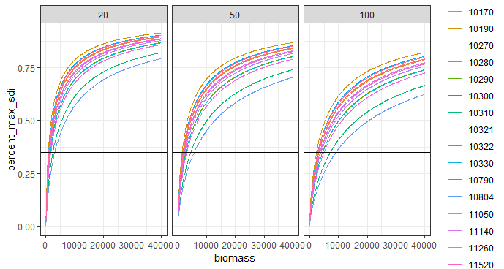

Figure 6. Biomass targets for 35% and 60% MaxSDI. For each BPS, the relationship between %MaxSDI and biomass differs and depends on stand age (panel labels). Biomass targets are derived from the intersection between the biomass-%MaxSDI curve and %MaxSDI = 0.35 or 0.60.

Using the map of MaxSDI (Fig. 3), we created three management zones: high SDI (red fir, Douglas-fir, and Sierra mixed-conifer), medium SDI (Jeffrey/Ponderosa pine), and low SDI (oak and juniper woodlands, shrublands). These were assigned biomass targets using the regression models predicting %MaxSDI from biomass and age (Fig. 6).

Treatments were largely similar to those applied by Maxwell et al. (2022), but typically with lower biomass thresholds for treatment. In general forests and private nonindustrial forests, mechanical thinning was prescribed on shallower slopes (<35%), and hand thinning was applied on slopes >35% (North et al. 2015). Treatments were applied such that each cell had a 6% change of being harvested each year, as long as it met treatment criteria. Private industrial forests were managed with clearcuts and precommercial thins, and wilderness and designated roadless areas were not silviculturally managed.

Three management alternatives were tested: one designed to maintain the landscape below 35%MaxSDI, another below 60% MaxSDI, and one which manages the landscape at 35%MaxSDI only in the WUI and in areas previously identified as being at high risk of fire.

# Limitations of the approach

Management zones and biomass targets are static – they don’t update with climate change, and concomitant changes in MaxSDI or age/biomass relationships.

These strategies might not be a good idea in the future, when we might be more concerned with regeneration failure than overstocking.